int age = 24;

string name = "Yasir";

string address = "Karak kpk Pakistan";

string birth = "17/01/1998";

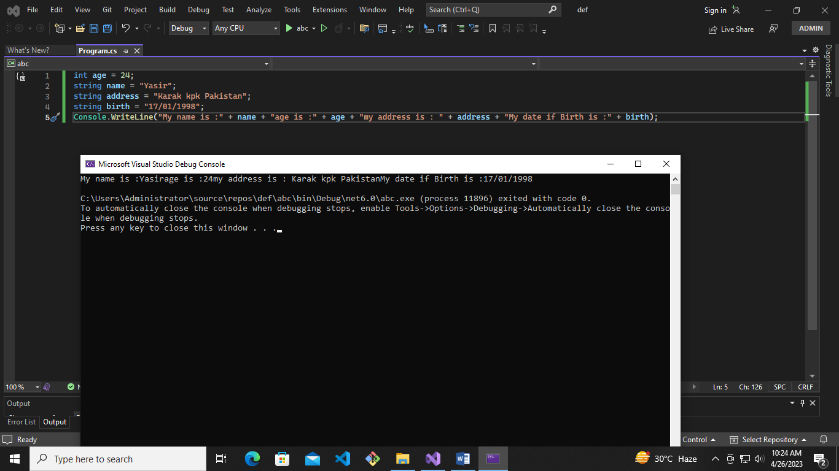Console.WriteLine("My name is :" + name + "age is :" + age + "my address is : " + address + "My date if Birth is :" + birth);